**CSC304 – Microprocessor Architecture and Assembly**

**Prepared by:**

**Name Roll No**

Musallam rashed alameri 1077505

**Submitted to:**

Dr Huma

**Question:**

Use the MDE 8051 microcontroller to design a 4 bit adder/subtracter in ASSEMBLY LANGUAGE. The user inputs two 4-bit binary numbers N and M on P3.0 to P3.3 and P3.4 to P3.7 The sum is sent to port P1.0 to P1.3 and the carry to P1.4. P2.0 is used to select either the addition or the subtraction operation.

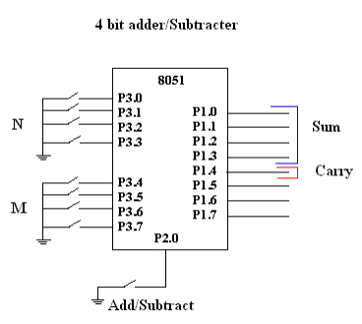

**Code:**

ORG 00h // starting of code

MOV A,#0FFH //mov FF to A

MoV P3,A // P3 as input port

MOV A,#00H // P1 as output port

MoV P1,A //mov FF to A

SETB P2.0 //p2.0 as input for add/sub

again:

JNB P2.0,SUB //P2.0 if pressed do sub operation else add

Acall Take_numbers //input both numbers from port3

Add A, R1 //do N-M

Mov P1, A // show them on P1

sjmp again // loop this process again

SUB: //subtraction operation

Acall Take_numbers //input both numbers from port3

CLR C // clear carry

Mov A,R1 // mov N to R1

subb A, R2 //do N-M

Mov P1, A // show them on P1

sjmp again // loop this process again

Take_numbers:

MOV A,P3 // mov inputs to A from P3

MOV R7,A // mov A in R7

MOv R6,A // copy in R6

ANL A,#0FH // first digit N

MOV R1, A // N in R1

MOV A, R6 // Mov R6,A

ANL A,#0F0H // second digit M

swap A // swap A

MOV R2, A // M in R2

RET

End